'Be kind, be curious, be you'

10th May 2024 Bulletin

Headteacher update:
I’m writing this on Thursday evening, feeling overwhelmed with pride after seeing so many of our school community together at our celebration this afternoon. Food is always such a great way to bring people together and today was a perfect way to share the traditions we hold dear in our families and cultures. We are really grateful for all those of you who took the time to come and our tummies are particularly grateful for all the amazing food that was bought to share!

We were impressed to see children trying lots of new tastes and flavours, and it was wonderful to see the enjoyment they got from telling others about food they had prepared. The afternoon itself was a true reflection of the great community we have here.

We hope that your children have been telling you all about their enrichment experiences this week and that you have seen the posts on social media. For those of you who have yet to catch up on the news, please check the blogs or keep an eye out for more Instagram or Facebook posts. Arriving from a meeting later today, I was welcomed by the sound of African beats and children's laughter as they danced partied in the dining hall. A real memory maker...

Huge thanks to Mrs Grant and Mrs Brand, for organising the event, and for FHIS for funding the dance and food master classes. If you haven't already, please complete the short survey with your child to let us know your child's opinion of their sense of belonging in our school. This will help us to plan for curriculum development from the point of view of our community. You can access the survey via the QR code in classroom windows, or this link.

For another way to support our school community, please either volunteer at or come to our Campus May Fair on Saturday 18th May. If this week's weather continues, we'll be in for a treat.

Have a great Weekend.

Best wishes,

Gemma Fricker

Photos and information about what has been happening in classes, the learning plans as well as important messages from teachers are all found in the class blogs (click below)

Curriculum Update: Food Sharing

We were treated to food from all across the globe from...
Ghana, India, The Philippines, Israel, Wales, Germany, Sweden, Syria, England, The Caribbean, Holland, Mauritius Jamaica, Italy, Spain, Scotland and more...

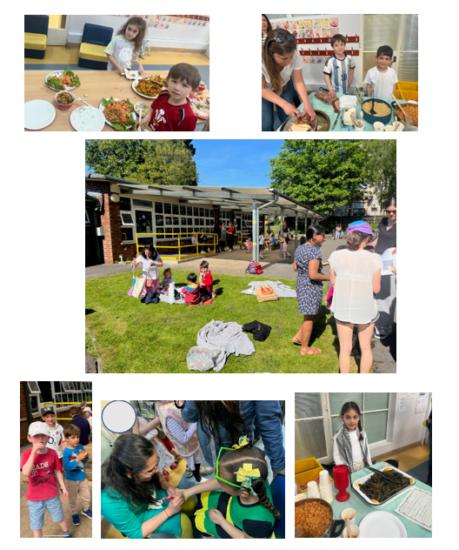
Coming up:
Wednesday 15th-Governor Day
Friday 17th 9:00-School nurse coffee morning on developing good sleep routines
Saturday 18th-May Fair

Looking ahead:
Sports Day 18th June 9:30-11:30
2024-25 INSET Days are on our school calendar

Click below for the school calendar

Buttercup Class: Saahas
Daisy Class: Huw
Daffodil Class: Everyone!
Bluebell Class: Lucas
Cherry Class: Everyone!
Maple Class: Hannah
Sycamore Class: James

Class of the Week: Bluebell Class for engagement and enthusiasm during all activities this week and for showing their community values in the way they learn and play together.

Another great week of children 'reading for the stars!'

Congratulations everyone!
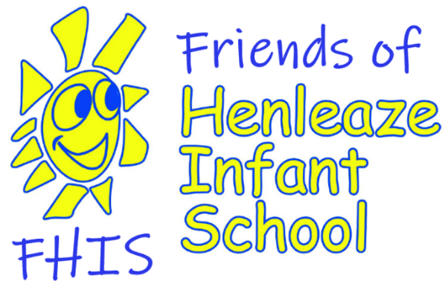
Here it is, the moment you’ve been waiting for!

After many months of planning the May fair is only 8 days away and now we need YOU

Please sign up for one or more slots to help us make our first May Fair as a new team as successful and fun as possible. Huge thanks in advance, your May Fair team. X

https://signupgenius.com/ https://m.signupgenius.com/#!/showSignUp/4090445ADA922A0F58-49486712-mayfair

DONATIONS
Please start bringing your much needed, fantastic donations (list below) for our fundraising stalls next week - last day for donations is Thursday 16-May

- nothing broken, dirty or incomplete - only good condition items that you'd be happy to buy yourself.

Second hand items
clean and very good condition cuddly toys
children's clothes and fancy dress
Games and toys
kid's books
second hand uniform (all welcome, but not unbranded t-shirts please)

RAFFLE TICKETS!!
We've got some brilliant prizes to be won - tickets on sale after school this week.

Click here for more news on the FHIS webpage:

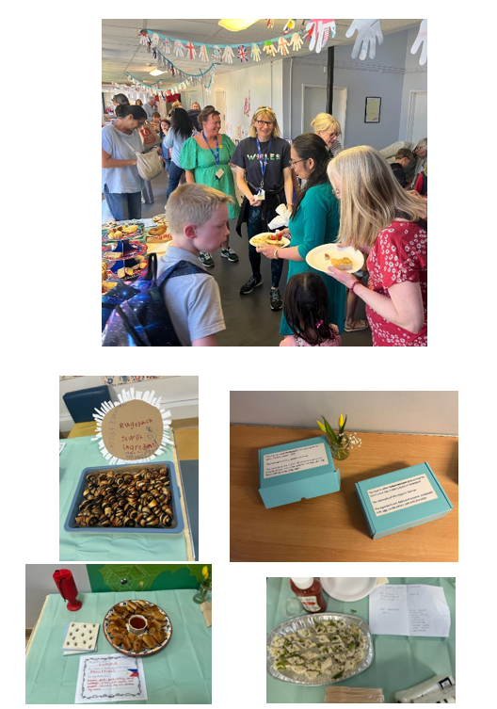

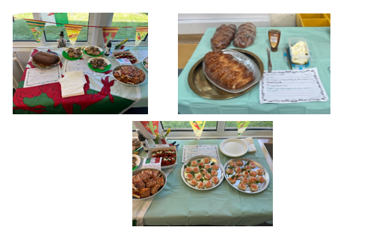

Important Messages:
Infectious diseases:
There are a number of confirmed cases (and suspected cases) of 'Slapped Cheek' (Parvovirus) in school. This virus can result in sore throat and temperature as well as the tell-tell rash on the cheeks giving the name. Children should not be in school if they have a temperature or sore throat associated with the virus, but when well and once the rash is visible can be in school. It can affect unborn children, so pregnant women who are exposed should seek advice. Please ensure you inform the school if your child has 'slapped cheek' so that we can keep our staff informed.
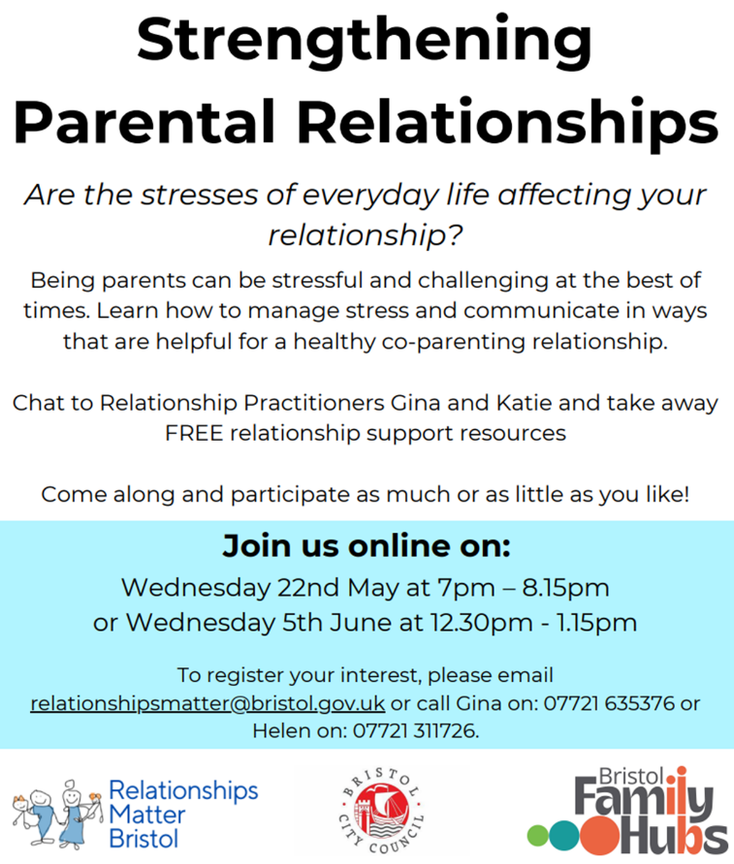

Bristol University Study: request for parent view
