 **Safeguarding Policy Summary for Parents**

We follow the [Cathedral Schools Trust Child protection and Safeguarding Policy 2024-25](https://www.cathedralschoolstrust.org/media/6870/cst-safeguarding-and-child-protection-policy-2024-2025.docx) 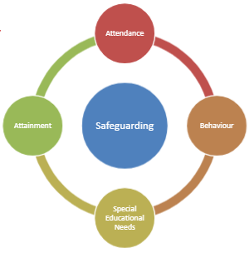

Rationale: At Henleaze Infant School we believe that safeguarding and promoting the welfare of children is **everyone’s** responsibility. **Everyone** who comes into contact with children, their families and carers, has a role to play. In order to fulfil this responsibility effectively, all professionals should make sure their approach is child centred. This means that they should always consider what is in the **best interests** of the child.

**We adhere to the ‘It could happen here’ message**

Principles:

* Children have a right to be safe, to be listened to, valued and respected.
* Parents and carers have a right to be informed of any concerns regarding their child.
* Children are best protected when parents and the school work together.
* All staff and volunteers are given appropriate training and support.
* All staff and volunteers are subject to rigorous recruitment checks.
* Through our Henleaze Infant School Curriculum children are taught how to stay safe

We will consult with appropriate outside agencies when there are concerns that a child may have been abused or neglected. We will discuss with parents/carers any concerns they have about children. Parents/carers will be kept informed of what has happened. Parents should report their concerns to our team.

**Designated Safeguarding Lead (DSL) Deputy DSLs Safeguarding Governor Safeguarding Partners:**

Gemma Fricker Ruth GibsonBeth Aviss Louise Walton

    